With traffic congestion currently resulting in an average personal commute time of 53 minutes daily (ABS 2012), this has a significant to cost to business and has a high impact of the health and wellbeing of individuals.

The utilisation of live Vic Roads bluetooth traffic data and Bureau of Meteorology forecasts and live weather data allows probabilistic recognition of potential traffic hot spots due to weather events and other weather related emergency incidents, during peak and non-peak road usage periods. This real time ongoing analysis of historical vs real-time traffic flows which takes into account predicted weather events can be utilised to make real-time pro-active decisions on traffic routing, and to encourage people to not travel during weather events, to travel outside of peak times if possible, or to recommend a variation to travel routes.

A smart Flow AI solution using this data will:

Improve health and wellbeing for individuals through increased time with families, friends and for leisure activates

Provide Safer driving on less congested roads, taking into inclement weather

Reduce the cost to business through happier and more productive staff

Lower the carbon footprint through more efficient use of vehicles

Reduce peak loads on Victoria’s traffic network.

The proposed solution could be expanded nationally where the equivalent traffic data is available.

SOLUTION:.

1. HISTORICAL SAMPLE OF THE PROBLEM: Olympic Park grid, good weather vs some rain and corresponding timings on Punt Road.

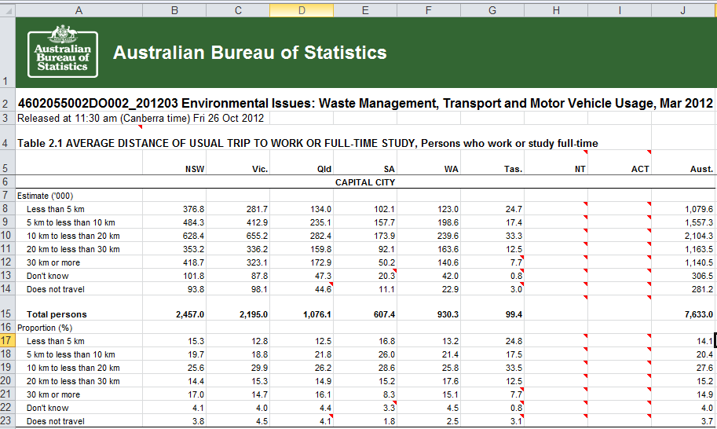

|  |  |
| --- | --- |
| **Dataset Name** | **URL** |
| Traffic Volumes for Freeways and Arterial Roads - Victorian Government Data Directory | <http://data.vicroads.vic.gov.au/metadata/filesvicroadsvicdatalatestmmwspeeddatabyroadsegment.html> |
| BlueTooth Data (GovHack 2017) - Victorian Government Data Directory | http://data.vicroads.vic.gov.au/Metadata/BlueTooth_Data.html |
|  |  |
| Road Works and Events Live - Lines (GovHack 2017) - Victorian Government Data Directory | <http://data.vicroads.vic.gov.au/metadata/Road_Works_Events_Points_Live.html> |
| Grid Forecasts API | https://api.cloud.bom.gov.au/forecasts/v1/grid |
|  |  |

**How datasets were used:**

**Traffic Volumes for Freeways and Arterial Roads - Victorian Government Data Directory**

This data was used to initially assess speed data for individual roads over various periods of time throughout a day. It was used to confirm peak traffic times and variation of average speeds between peak and non-peak periods.

**BlueTooth Data (GovHack 2017) - Victorian Government Data Directory**

A snapshot of historical data from June 2017 was used to verify specific travel times along sections of road to determine if these travel times could be used as an ongoing measurement. It is proposed that ongoing recording of this data would enable effective monitoring and prediction of traffic flows, taking into account the impact of weather related events, rainfall, etc

Using the Real-time Bluetooth API, it would further build this dataset, looking for variation of traffic speeds outside of normal patterns, as well as variation based on forecast and actual weather conditions using the Bureau of Meteorology Grid forecasts API.

There is potential to expand this measurement to include further roads outside of the existing Bluetooth network by using Google APIs, but this may have limitations in comparison between live and historical data.

**Grid Forecasts API - Bureau of Meteorology (BOM)**

The publicly available rainfall dataset was used to compare traffic times for a specific day for which we had a Bluetooth traffic dataset available month of June, specifically the 30th.

Going forward, it is proposed to utilise the Grid Forecasts API, which provides forecasts at 3hr intervals over a 6 day period. This API data, when applied with corresponding traffic data can then highlight when further potential traffic delays and congestion is expected due to weather, enabling further automated routing of traffic based on predictive data analysis.

**Road Works and Events Live - Lines (GovHack 2017) - Victorian Government Data Directory**

This API has not been used directly in the analysis applied. It should be noted however, that road works and events should be considered as to how they may impact longer term the averages for traffic times and road speed, unless the road works or events are still in place and intended to remain in place for some time.

Traffic picture – congestion

Grumpy driver with poor health and wellbeing (maybe business?) – bring back to awards

Snapshot – of traffic data from ABS

Proof of slow traffic in peak hr / bad weather

Encourage businesses to allow staff to be more flexible in staff start and finish times

Staff opt in to an App for flex start and finish times

Show how the AI closed feedback loop assesses the probability of traffic volumes being excessive

Example – the night before or on the morning of a day of travel:

Notification is sent to staff members about optimised travel times for the day, within user defined thresholds

On the day:

Vicroads traffic management continually re-assessing and optimising traffic flow based on predicted flows determined by actual historics flows compared to actual historic weather data corresponding 3 hr forecasts.

For Vic Roads – improved traffic flow and management (show how vehicles per hr metric improved)

For the Individual – better health and wellbeing and better use of their time (bring back to awards)

For the enterprise – better productivity and less impact to their business.